CONFERENCE SPEAKER DIRECTORY
@CREATIVITY THINK (9483175986/7019689991)

ABSTRACT:
The Conference Speaker Directory is a web-based platform designed to organize, manage, and showcase speaker profiles for events, conferences, seminars, and academic gatherings. It centralizes speaker information, expertise categories, event assignments, and feedback collection in a structured and efficient system. Users can search and filter speakers by expertise, review profiles, assign speakers to events, and provide feedback after sessions. Administrators manage speaker data, oversee event assignments, and track analytics through interactive dashboards. Developed using Django with Django Rest Framework on the backend and React with axios and recharts on the frontend, the platform ensures accuracy, scalability, and a user-friendly experience for professional event management..

INTRODUCTION OF THE PROJECT:
Event organizers often face challenges in managing speaker details, verifying expertise, coordinating event assignments, and collecting post-session feedback. Without a centralized system, managing speaker information becomes inefficient and error-prone. The Conference Speaker Directory provides an organized digital solution to store speaker details, expertise tags, event participation data, and feedback. The platform offers users an easy way to discover suitable speakers while enabling administrators to maintain updated directories, track participation, and analyze audience responses. This project aims to simplify speaker management for venues, event agencies, and educational institutions by delivering a reliable and interactive interface..

PROJECT OBJECTIVES:

• Provide a centralized directory for speaker profiles
• Allow users to search and filter speakers by expertise
• Enable event assignment and scheduling for speakers
• Facilitate feedback collection from participants
• Provide a dashboard with charts for analytics and performance
• Allow administrators to add, edit, and manage speaker details
• Ensure smooth navigation and accessibility across the system
• Support scalable backend APIs for robust data handling

PROBLEM OF THE STATEMENT:
Managing speaker information traditionally involves spreadsheets, emails, and scattered communication channels. This leads to data inconsistency, difficulty in finding the right speaker, missing event history, and lack of structured feedback. Event agencies and institutions struggle to maintain accurate speaker records and generate analytics. The Conference Speaker Directory resolves these issues by establishing a centralized, searchable, and analytics-enabled system that maintains detailed speaker profiles, manages event roles, and records participant feedback effectively..

MOTIVATION OF THE PROJECT:
• To create a structured and accessible database of conference speakers
• To reduce manual errors and scattered data management
• To provide a simplified speaker search and filtering mechanism
• To support event organizers in assigning speakers to events efficiently
• To record and analyze participant feedback for quality improvement
• To offer administrators a powerful dashboard for operational insights
• To enhance the professional management of conferences and academic events

BLOCK DAIGRAM OF PROJECT:

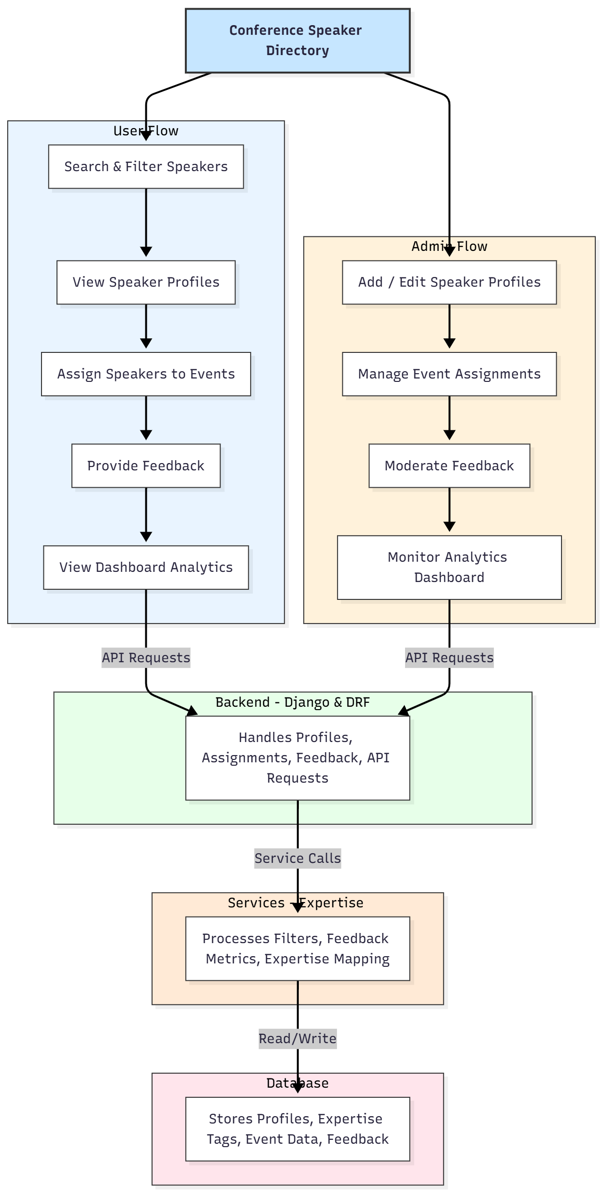

WORKING OF THE PROJECT:
The system begins with administrators creating and updating speaker profiles containing details such as name, expertise tags, biography, and contact information. Users search for speakers based on expertise, category, or availability and review detailed profiles. Event organizers can assign speakers to upcoming events, and participants can submit feedback after sessions. The backend handles all data processing, while the services module manages expertise-based search optimization and feedback analytics. Administrators access dashboards generated through recharts to analyze speaker performance and audience feedback. All profiles, events, and feedback entries are stored in the database for continuous reference..

SOFTWARE REQUIREMENT:
- Backend:
  - Python 3.x
  - Django
  - Django REST Framework
  - SQLite/PostgreSQL
- Frontend:
  - Node.js and npm
  - React.js
  - Axios
- Development Tools:
  - Visual Studio Code
  - Postman (for testing APIs)
  - Git/GitHub (for version control)
- Server/Deployment (Optional):
  - Gunicorn, Nginx, or Heroku/AWS for hosting

ADVANTAGES OF THE PROJECT:

• Centralized management of speaker profiles
• Fast and accurate speaker search using expertise filters
• Easy assignment of speakers to multiple events
• Feedback-driven performance analysis
• Reduces miscommunication and manual data entry
• Provides interactive dashboards for decision-making
• Enhances the professionalism of events and conferences
• Scalable for agencies, universities, and large institutions

APPLICATIONS OF THE PROJECT:
• Event management agencies
• Universities and colleges
• Professional conference organizers
• Seminar and workshop coordinators
• Corporate training departments
• Government and NGO event departments

REFERENCES:

- Django REST Framework Documentation — Django Software Foundation. Django Documentation. Available: https://docs.djangoproject.com/
- Django REST Framework. DRF Documentation. Available: https://www.django-rest-framework.org/
- React. React Official Documentation. Available: https://reactjs.org/docs/getting-started.html
- Redux. Redux Documentation. Available: https://redux.js.org/introduction/getting-started
- PostgreSQL Global Development Group. PostgreSQL Documentation. Available: https://www.postgresql.org/docs/
- MySQL. MySQL Reference Manual. Available: https://dev.mysql.com/doc/
- Git. Git Documentation. Available: https://git-scm.com/doc
- Node.js. Node.js Documentation. Available: https://nodejs.org/en/docs/
- Axios. Axios Documentation. Available: https://axios-http.com/docs/intro
- Socket.io Documentation – https://socket.io/docs/

